- Given the following columns from a mock Zomato restaurant dataset — Restaurant Name, Cuisine Type, Average Cost for Two, User Rating, City, and Open/Closed Status — classify each column as either Numerical (Continuous or Discrete) or Categorical (Nominal or Ordinal).
ANSWERS:

GreenLine are Nominal or Ordinal.
RedLine are continuous or Discreate
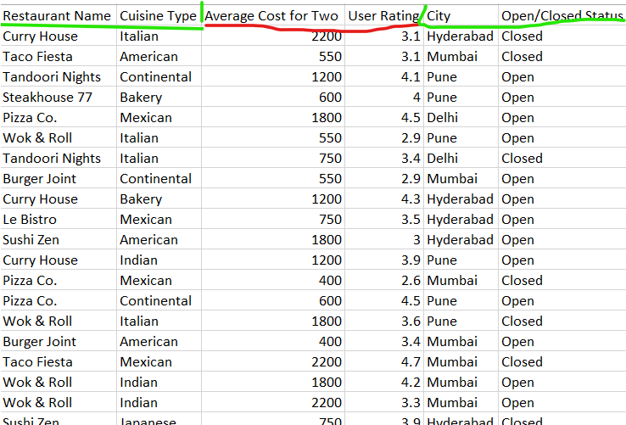

- Create a table with 8 real-life examples (not from class) of data you might find in popular apps like Instagram, Flipkart, or IRCTC. For each, specify the measurement scale (Nominal, Ordinal, Interval, or Ratio) and briefly explain your choice.

Hint: Think about things like 'Order Status', 'Train Departure Time', 'Number of Likes', or 'Payment Method'.
ANSWERS:
FLIPKART
ProductNames | strings | Ordinal
Categories & Subcategories | strings | Nominal
Price & Quantity | int | Continuous & discreate

- Given this time-series data from a Spotify user's listening history — Date, Song Name, Play Count per Day — identify which columns represent time-series, and which are categorical or numerical. Explain your reasoning.
ANSWERS:
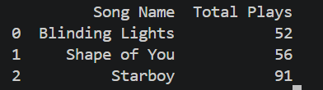

- Write a function or pseudocode that takes a column of data (array of values) from a Flipkart order history and automatically detects whether it is likely Nominal, Ordinal, Interval, or Ratio scale. Briefly describe the logic used for each type.
Constraint: You do not need to write a perfect algorithm — focus on simple rules based on value types and patterns.
ANSWERS:
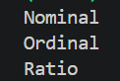

Simple Logic Description (What to write in your assignment)
- Nominal: If the data is text (words) and doesn't represent a process, it is just a label (e.g., UPI, Credit Card).
- Ordinal: If the data is text but the column name implies a step-by-step progress (like Order Status: Ordered $\rightarrow$ Shipped $\rightarrow$ Delivered).
- Interval: If the data is a number representing calendar dates or clock times, where zero is just a placeholder on a timeline.
- Ratio: If the data is a number representing counts or money (like Price or Quantity), where a value of 0 literally means "nothing exists."

